Poster Abstract

Title of Your Abstract
John P. Smith¹ and Other Authors¹
¹Department of Chemistry, Institution name
²Department of Chemistry, Institution name

Your abstract text goes here, 300 words max. Use Font size 12 Arial as the minimum font size for the abstract. Please, use A4 paper size with 2 cm minimum page margins. Do not exceed one page.
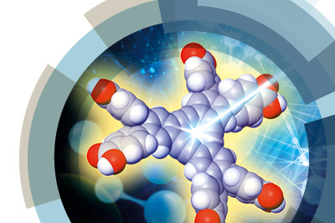
Figure 1. Figure caption describing the figure context: font size 10 Arial.

REFERENCES: (1) Doe, J.; et al. Chemical Science, 2020, 1, 1-11. (2) other relevant references go here. Font size 11 Arial suggested.
ACKNOWLEDGEMENTS: relevant funding sources etc go here.

